**Угрюмов Михаил, ИУ5-34Б, вариант – 23(Г)**

**Рубежный контроль №2**

**Текст программы:**

main.py

class Language:  
 *''' язык программирования '''* def __init__(self, id, name):  
 self.id = id  
 self.name = name  
  
class Library:  
 *''' библиотека языка программирования '''* def __init__(self, id, name, func_num, lang_id):  
 *''' func_num - количество функций в библиотеке'''* self.id = id  
 self.name = name  
 self.func_num = func_num  
 self.lang_id = lang_id  
  
class Link:  
 *''' связь библиотеки с языком '''* def __init__(self, lib_id, lang_id):  
 self.lib_id = lib_id  
 self.lang_id = lang_id  
  
def get_db_links(langs, libs, links):  
 *''' связь один-ко-многим'''* one_to_many = [(lib.name, lib.func_num, lang.name)  
 for lib in libs  
 for lang in langs  
 if lib.lang_id == lang.id]  
  
 many_to_many_temp = [(lang.name, link.lang_id, link.lib_id)  
 for lang in langs  
 for link in links  
 if lang.id == link.lang_id]  
  
 ''' связь много-ко-многим'''  
 many_to_many = [(lib.name, lib.func_num, lang_name)  
 for lang_name, lang_id, lib_id in many_to_many_temp  
 for lib in libs if lib.id == lib_id]  
  
 return (one_to_many, many_to_many)  
  
def task_1(one_to_many, symbol):  
 *''' returns languages which starts with symbol and all it`s libraries'''* ans = {}  
 for lib_name, x, lang_name in one_to_many:  
 if lang_name[0] == symbol:  
 if lang_name in ans:  
 ans[lang_name].append(lib_name)  
 else:  
 ans[lang_name] = [lib_name]  
 return ans  
  
def task_2(one_to_many):  
 *''' returns languages with max functions numbers in one library of each language  
 languages are sorted by these numbers'''* ans = {}  
 for x, func_num, lang_name in one_to_many:  
 if lang_name in ans:  
 ans[lang_name] = max(ans[lang_name], func_num)  
 else:  
 ans[lang_name] = func_num  
 ans = {key: value for key, value in sorted(ans.items(), key=lambda item: item[1])}  
 return ans  
  
def task_3(many_to_many):  
 *''' returns list of pairs (language, library)  
 languages are sorted by names  
 libraries in one language are not sorted'''* ans = []  
 for lib_name, x, lang_name in many_to_many:  
 ans.append((lang_name, lib_name))  
 ans = sorted(ans, key=lambda item: item[0])  
 return ans  
  
def main():  
 langs = [  
 Language(1, "Python"), Language(10, "Python v0"),  
 Language(2, "C++"), Language(20, "C++ v0"),  
 Language(3, "Pascal"), Language(30, "Pascal v0"),  
 ]  
  
 libs = [  
 Library(11, "random", 30, 1),  
 Library(12, "math", 50, 1),  
 Library(21, "vector", 40, 2),  
 Library(22, "algorithm", 20, 2),  
 Library(31, "Graph", 10, 3)  
 ]  
  
 links = [  
 Link(11, 1), Link(11, 10),  
 Link(12, 1), Link(12, 10),  
 Link(21, 2), Link(21, 20),  
 Link(22, 2), Link(22, 20),  
 Link(31, 3), Link(31, 30)  
 ]  
  
 one_to_many, many_to_many = get_db_links(langs, libs, links)  
  
 print('\nЗадание 1')  
 ans_1 = task_1(one_to_many, 'P')  
 print(*ans_1.items())  
  
 print('\nЗадание 2')  
 ans_2 = task_2(one_to_many)  
 print(*ans_2.items())  
  
 print('\nЗадание 3')  
 ans_3 = task_3(many_to_many)  
 print(*ans_3)  
  
if __name__ == '__main__':  
 main()

TestDataBase.py

import unittest as ut  
from main import *  
  
class TestDB(ut.TestCase):  
 def setUp(self):  
 self.langs = [  
 Language(1, "Python"), Language(10, "Python v0"),  
 Language(2, "C++"), Language(20, "C++ v0"),  
 ]  
  
 self.libs = [  
 Library(11, "random", 30, 1),  
 Library(12, "math", 50, 1),  
 Library(21, "vector", 40, 2)  
 ]  
  
 self.links = [  
 Link(11, 1), Link(11, 10),  
 Link(12, 1), Link(12, 10),  
 Link(21, 2), Link(21, 20)  
 ]  
  
 self.one_to_many, self.many_to_many = get_db_links(self.langs, self.libs, self.links)  
  
 self.ans_1 = {'C++' : ['vector']}  
 self.ans_2 = {'C++' : 40, 'Python' : 50}  
 self.ans_3 = [('C++', 'vector'), ('C++ v0', 'vector'), ('Python', 'random'), ('Python', 'math'), ('Python v0', 'random'), ('Python v0', 'math')]  
  
 def test_task_1(self):  
 self.assertEqual(task_1(self.one_to_many, 'C'), self.ans_1)  
  
 def test_task_2(self):  
 self.assertEqual(task_2(self.one_to_many), self.ans_2)  
  
 def test_task_3(self):  
 self.assertEqual(task_3(self.many_to_many), self.ans_3)  
  
if __name__ == '__main__':  
 ut.main()

**Результаты работы программы:**

TestDataBase.py

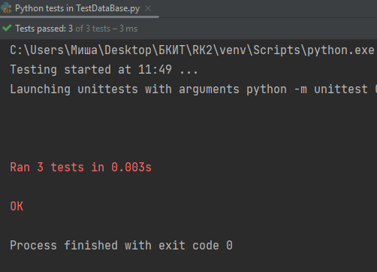

main.py

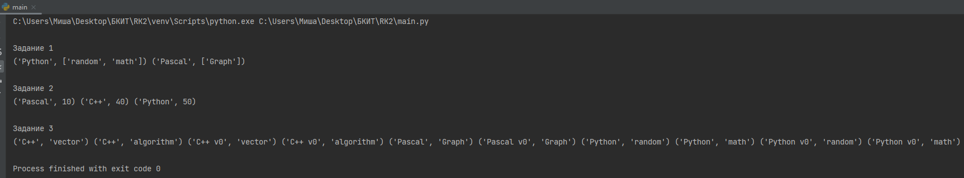

В текстовом виде:

Задание 1

('Python', ['random', 'math']) ('Pascal', ['Graph'])

Задание 2

('Pascal', 10) ('C++', 40) ('Python', 50)

Задание 3

('C++', 'vector') ('C++', 'algorithm') ('C++ v0', 'vector') ('C++ v0', 'algorithm') ('Pascal', 'Graph') ('Pascal v0', 'Graph') ('Python', 'random') ('Python', 'math') ('Python v0', 'random') ('Python v0', 'math')

Process finished with exit code 0